The original pricing information was gathered directly from public energy provider websites (e.g., SureCharge, Believe, Ubitricity, BP Pulse) [1,2,3,4].

Figure 1: SureCharge – Raw Tariff Information (Website Extract)

Figure 2: Believ – Raw Tariff Information (Website Extract)

Figure 3: Ubitricity – Raw Tariff Information (Website Extract)

Figure 4: Bppulse – Raw Tariff Information (Website Extract)

The raw pricing data included inconsistent formats, varying currencies (pence/kWh vs £/kWh), and heterogeneous fee structures (energy rates, idle fees, connection fees). To ensure comparability, we standardised units, harmonised VAT inclusion, and separated the data into three structured datasets: pricing_core (base tariffs), pricing_conditions (time-of-use, idle rules), and pricing_by_charger_type (connector/power-based overrides). These structured datasets were integrated into the charging cost estimation module, enabling the reinforcement learning environment to compute realistic, provider-specific charging session costs.

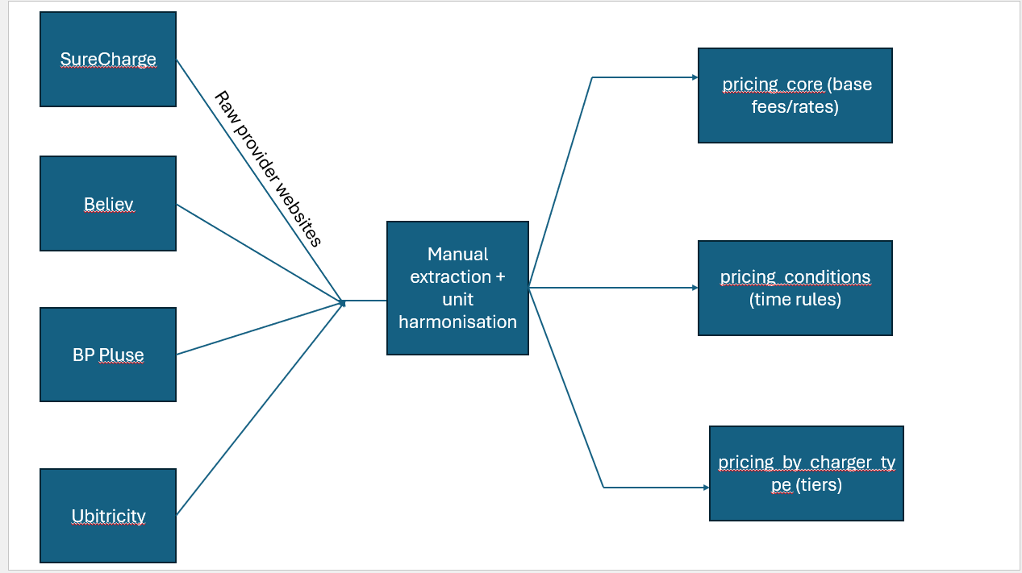

Figure 5: Pricing Data Collection and Processing Pipeline

The original charging station dataset was obtained from the National Chargepoint Registry (NCR), archived by the UK Department for Transport [5]. We cleaned duplicates, standardised geolocations, and separated connector details from station metadata, producing two datasets: *charging_station_connectors* and *charging_station_metadata*. These cleaned datasets support station feature generation and action feasibility within the RL environment.

Figure 6: Charging Station Data Cleaning and Splitting Process

EV specifications and charging curves were sourced from Open EV Data v2 [6]. We parsed JSON shards to extract usable_battery_size, AC/DC ports/power, energy_consumption and charging_curve points. Cleaning: standardised plug names, converted consumption to kWh/km, interpolated 0–100% curves, capped powers. Used to build EV_Metadata and EV_Charging_Curve_Data powering SOC and charging-time.

Figure 7: EV Data Extraction and Normalisation Pipeline

References

1. FM Conway. (n.d.) *SureCharge pricing.* Available from: [https://www.fmconway.co.uk/our-services/electric-vehicle-charging/faqs#:~:text=How%20much%20does%20SureCharge%20cost,midnight%20Friday%20to%20midnight%20Sunday](https://www.fmconway.co.uk/our-services/electric-vehicle-charging/faqs?utm_source=chatgpt.com#:~:text=How%20much%20does%20SureCharge%20cost,midnight%20Friday%20to%20midnight%20Sunday) [Accessed 29 August 2025].
2. BP Pulse. (n.d.) *Public EV charging pricing.* Available from: [https://www.bppulse.com/en-gb/public-ev-charging/pricing](https://www.bppulse.com/en-gb/public-ev-charging/pricing?utm_source=chatgpt.com) [Accessed 29 August 2025].
3. Ubitricity. (n.d.) *Driver pricing.* Available from: [https://ubitricity.com/en/driver/pricing/](https://ubitricity.com/en/driver/pricing/?utm_source=chatgpt.com) [Accessed 29 August 2025].
4. Believ. (n.d.) *Driver pricing.* Available from: [https://www.believ.com/drivers/pricing/](https://www.believ.com/drivers/pricing/?utm_source=chatgpt.com) [Accessed 29 August 2025].
5. UK Department for Transport. (2025) *National Chargepoint Registry (NCR) dataset [archived version, supplied on request]*. Provided to author via email communication, March 2025.
6. KilowattApp. (n.d.) *Open EV Data v2.* GitHub. Available from: [https://github.com/KilowattApp/open-ev-data/tree/master/data/v2](https://github.com/KilowattApp/open-ev-data/tree/master/data/v2?utm_source=chatgpt.com)